Marine Fish – Part 1
Kingdom:
Phylum:
Subphylum:
- What structure do all fish possess (which will later become a backbone)?
- What is the name for the study of fish?
- What are the 6 typcial fish characteristics?

Agnatha:
- What does “agnatha” mean?
- Are these fish primitive or complex?
- Why are their numbers falling?
- How do they eat?
- Do they have fins? Scales?
- Examples?
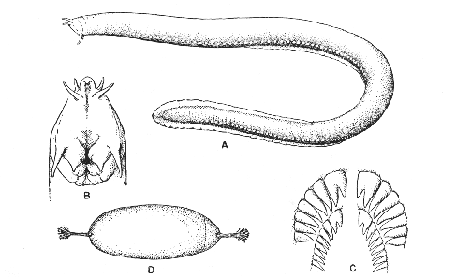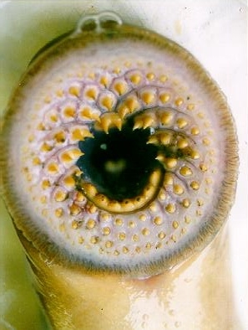
Chondrichthyes:
- What type of skeleton do these fish have?
- Where is their mouth?
- What are their teeth like?
- Examples?
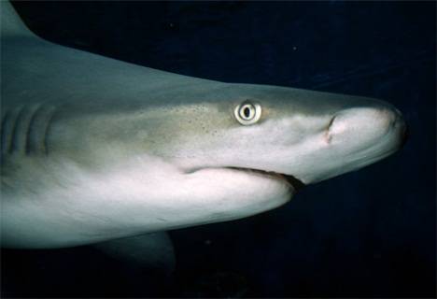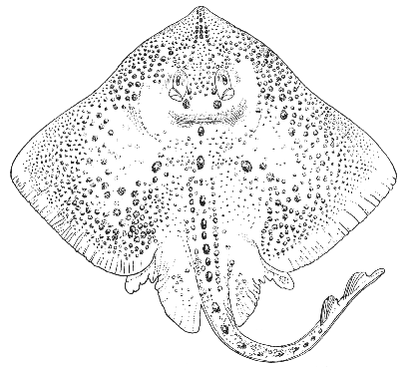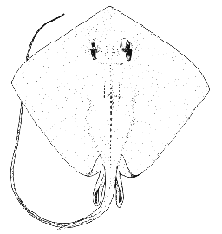
Osteichthyes:
- What type of skeleton do these fish have?
- How are they doing population wise?
- Where is their mouth?
- How do they control buoyancy?
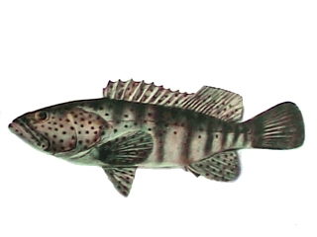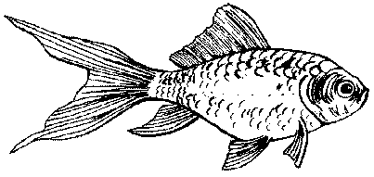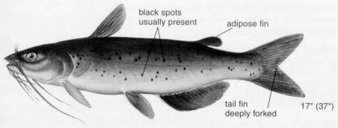

Body forms:
- What is body shape related to?
- Fusiform:
  - What are these built for?
  - Why are they more efficient at this?

  - Examples:
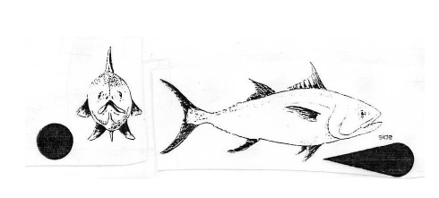
- Compressed:
  - Describe.
  - Why are they shaped this way?
  - Examples:
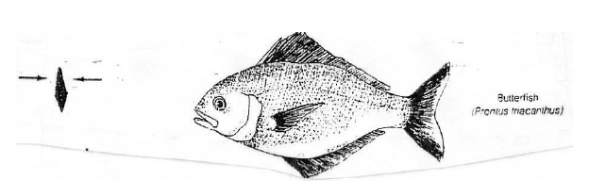
- Attenuated:
  - How are these shaped?
  - Where do they live?
  - Slimy or “dry” skin?
  - Examples:
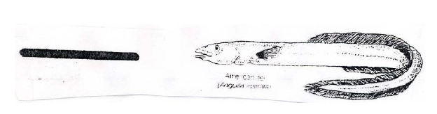
- Depressed:
  - How are these shaped?
  - Where do they normally live?
  - Examples:
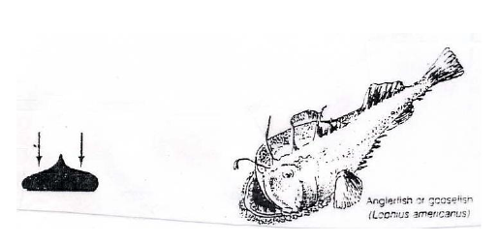

Fins
- What is the main purpose of fins?
- List the 6 fins:
- How do fins differ in cartilaginous versus bony fish?
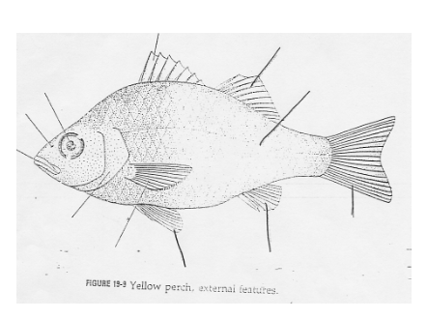
- Caudal fins:
  - Heterocercal
    - Who has this?
    - Why do they need this?
    - How do pectoral fins help?
  - Diphycercal:
    - Lobes?
    - Example:
  - Homocercal
    - Who has these?
    - What is distinctive about these lobes?
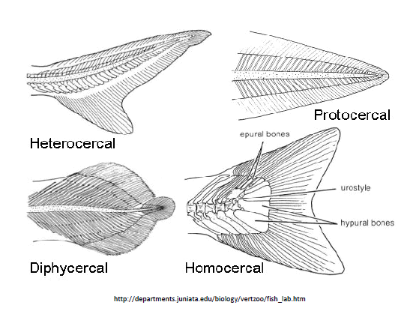
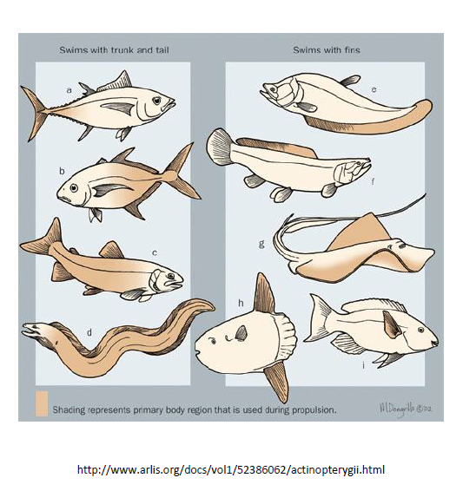
Fish Notes Part 2
- What is the shape of the mouth related to?
  - Razor sharp teeth =
  - Needle sharp teeth =
  - Do all chase their prey?
- Nibblers/grazers:
  - Large or small bites of food?
  - Examples?
- Strainers:
  - Where do they get their food?
  - Examples:
- Suckers
  - How do they gather food?
  - Why do many have barbels?
  - Examples?
- Parasitic
  - Where do they get their food?
  - Examples?
- Digestive system:
  - List the organs food flows through – in order:
  - What is unique about the esophagus?
  - How are the stomachs different?
  - Who has a longer intestine – carnivores or herbivores?
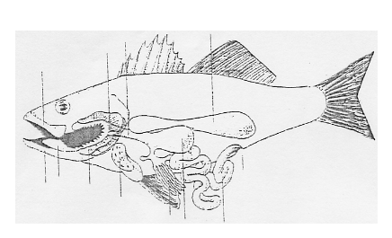
- Buoyancy control
  - What structure enables fish to move up and down in the water column?
  - In what two ways can they fill their swim bladder with air?
  - What is neutral buoyancy?
  - Cartilagenous fish do not have a swim bladder. What do they do instead?
  - What is the difference between descension and ascension?
  - How are the open and closed systems different?
- Temperature – are fish endothermic or exothermic?
  - What happens to their metabolism as the temperature increases?
  - What is the purpose of a countercurrent system?
- Circulatory system
  - How many chambers are in a fish’s heart? A human’s?
  - Do their red blood cells have a nucleus?
- Respiration
  - What organ extracts oxygen from the water?
  - Show the flow of air/oxygen through the fish’s body:

  - What is the job of the operculum in fish?
  - How does “gulping” air help some fish?
  - Why are lungfish called this?
- Excretion and salt water balance
  - What is excretion?
  - What 2 organs are primarily involved?
  - What is the salinity of marine fish? The ocean?
  - What are chloride cells?
  - Why is osmoregulation so important?
  - How do salt water fish maintain homeostasis in regards to water/salt?
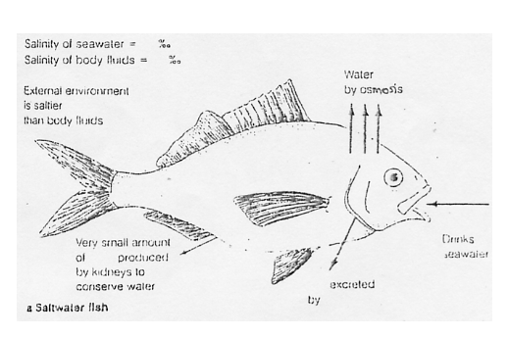
  - How do fresh water fish maintain homeostasis in regards to water/salt?
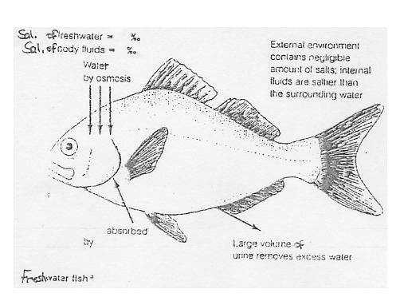
Fish Notes – Part 3
- Skin
  - Is the skin alive?
  - Are the scales on the outside of the skin?
  - What are the two main functions of mucus on fish?
  - What causes the “fishy” odor?
  - What can this be used for?
- Scales
  - Do they have more as they get older?
  - How can you “age” a fish?
  - Name 2 fish without scales.
  - Types:
    - Placoid
      - What are these like?
      - What do they feel like?
      - Examples:
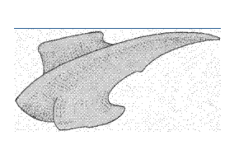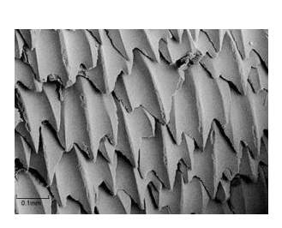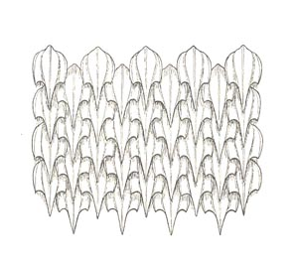
    - Ganoid
      - What are these like?
      - Examples:
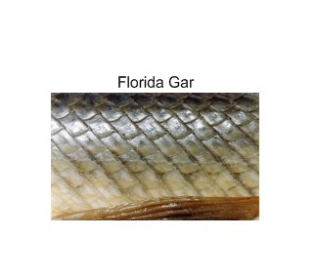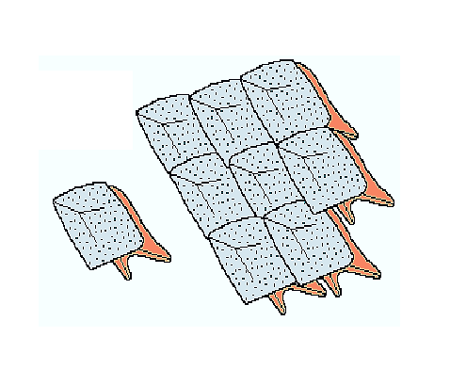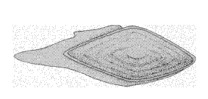
    - Cycloid
      - What are these like?
      - Examples:
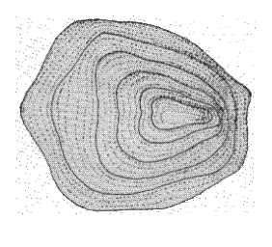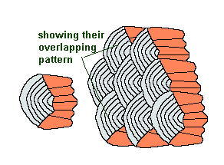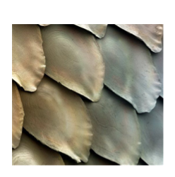
    - Ctenoid
      - What are these like?
      - Examples:
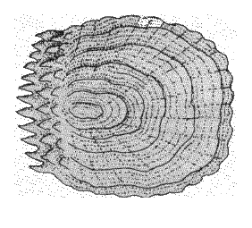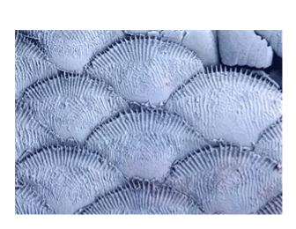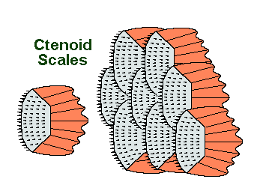

- Coloration
  - What is the point of coloration – why do fish have it?
  - How are they colored – what 2 cells cause color?
- Defensive strategies
  - How do modified scales provide defense?
  - What good is a prehensile tail on a seahorse?
  - What strategy does the puffer fish use?
  - What is countershading and how does it help a fish?
  - What is the point of disruptive contrast?
  - What are secretions?
  - Why school?
  - How might a fish try to intimidate you?
- Migrations:
  - For what 2 reasons will fish migrate?
  - Two types of migratory fish:
    - Anadromous
      - Where are they born?
      - Where do they live?
      - Where do they breed?
      - Example:
    - Catadromous
      - Where are they born?
      - Where do they live?
      - Where do they breed?
      - Example:
- Reproduction
  - Sexual or asexual?
  - Internally or externally?
  - What is spawning?
  - What is milt?
  - What is roe?
  - Dioecious or hermaphroditic?
  - What is an ovotestes?
  - What is sex reversal? Name 2 types of fish that can do this.
  - What can control the hormones that control the urge to breed?
  - What are 3 courtship rituals fish may go through?

